Data entry instructions.

1. Open “BITH*_*winter_survey_data_entry.xlsx”.
2. This spreadsheet contains 4 tabs:
   1. Point information
      1. Contains all of the information that describes each survey point.
   2. Count data
      1. Contains results of the bird surveys conducted at each point.
   3. Column descriptions
      1. Contains descriptions of each column of data to be entered on this spreadsheet.
   4. Lookup codes
      1. This is a locked sheet that contains lists that populate the drop-down menus encountered during data entry.)
3. Begin by entering data into the “Point information” tab. *You cannot enter survey results into the “Count data” tab until you have recorded information about the survey point.*
   1. Locality: the name of the island or country where the survey was conducted.
   2. Site: A unique code or name that describes the location of the surveys. A site usually contains groups of points. For example, if you conducted surveys at two protected areas, you might use the name of each area as the “Site” descriptor.
   3. Point.ID: A unique code or name that describes each point where you conducted surveys. Every point in the study must have a unique Point.ID.
   4. Observer: Initials of the observer who counted the birds during the survey.
   5. Visit: If you surveyed points multiple times during a study, assign each visit a unique number: first visit = 1, second visit = 2, etc.
   6. Time.1: The time (hh:mm), using a 24-hour clock, that the first count began. This data sheet assumes you are using the standardized survey consisting of four, 2.5-minute counts.
   7. Time.2: The time (hh:mm) that the second count began.
   8. Time.3: The time (hh:mm) that the third count began.
   9. Time.4: The time (hh:mm) that the fourth count began.
   10. X.coordinate: The latitude of the point in decimal degrees. This must be entered into the spreadsheet, even if you have the coordinates stored elsewhere (e.g., on a GPS or within a GIS).
   11. Y.coordinate: The longitude of the point in decimal degrees. This must be entered into the spreadsheet, even if you have the coordinates stored elsewhere (e.g., on a GPS or within a GIS).
   12. Wind.speed: Wind speed, recorded using the categories provided on the data sheet (see also “Lookup codes”).
   13. Wind.direction: Wind direction, recorded using the categories provided on the data sheet (see also “Lookup codes”).
   14. Sky: Sky conditions, recorded using the categories provided on the data sheet (see also “Lookup codes”).
4. Once you have entered data for a point on the “Point information” tab, proceed to the “Count data” tab and enter results of the survey.
   1. Site: You can only enter a Site that has already been recorded on the “Point information” tab.
   2. Point.ID: You can only enter a Point.ID that has already been recorded on the “Point information” tab.
   3. Survey.number: To which of the four repeated counts do these data pertain?
   4. Species: The standardized four-letter code for the species that you detected. Codes have been standardized using English names and you may only enter codes that have been stored on the “Lookup codes” tab. If you do not know the English name of the species, you may search the “Lookup codes” tab for the scientific name and its associated four-letter code.
   5. Distance: How far away was the bird? You may only enter the distance categories used in the standardized survey.

Data storage instructions.

1. It is recommended that you back-up this file after each data entry session. One file can remain on your computer, but a copy should be stored on a removable disk, a different computer in a different location, or on a remote server (e.g., Dropbox). If you do not have any means to back-up a file, please contact John Lloyd ([jlloyd@vtecostudies.org](mailto:jlloyd@vtecostudies.org)).
2. After all data have been entered, email the final copy to John Lloyd ([jlloyd@vtecostudies.org](mailto:jlloyd@vtecostudies.org)).
3. After all data have been entered, make photocopies of all data sheets and send by mail to Vermont Center for Ecostudies. Alternatively, you may email scanned version of the data sheets to John Lloyd ([jlloyd@vtecostudies.org](mailto:jlloyd@vtecostudies.org)).

General instructions.

1. Missing data are recorded as “N/A”. Any other code, including a blank cell, is unacceptable.

Example data sheet:

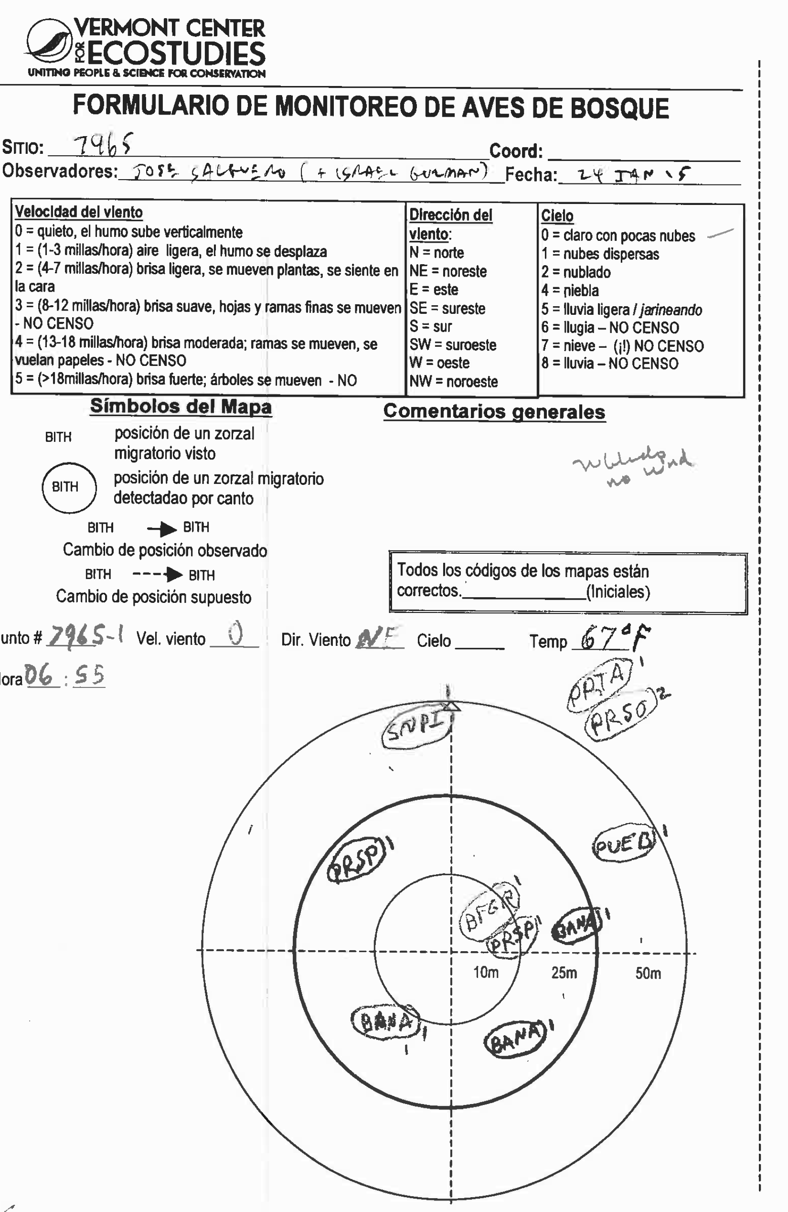

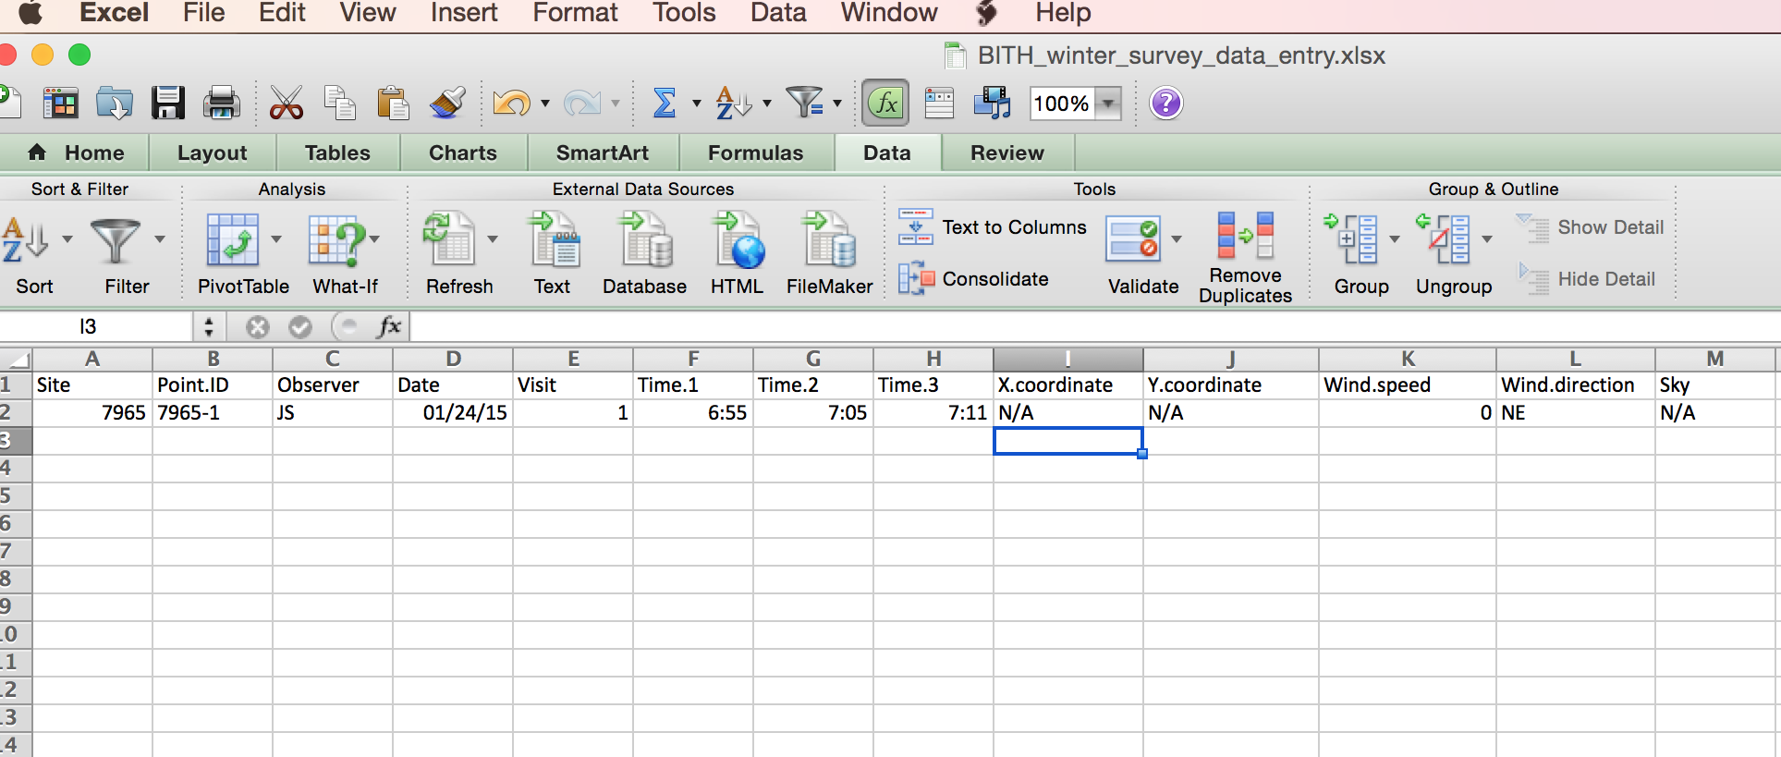 “Point Information” tab for example data (note missing data as N/A):

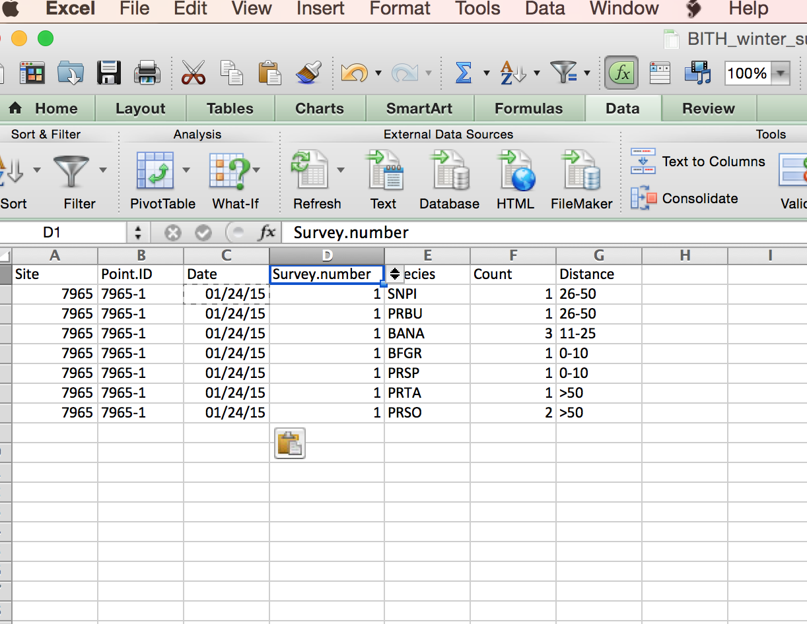“Count data” tab for example data.

Frequently asked questions.

1. Why can’t I enter the four-letter code for the species that I detected?

Answer: The code that you attempted to enter is not on the standardized list. Search the “Lookup codes” tab for the English or scientific name of the species you detected, and note the corresponding four-letter code. If you cannot find the species that you detected after searching for scientific name, please contact John Lloyd ([jlloyd@vtecostudies.org](mailto:jlloyd@vtecostudies.org)).

1. Can I leave cells blank if I don’t know what to enter?

Answer: No. All cells must be completed. If you don’t have data to enter for a particular call, enter “N/A” (without the quotations). N/A is the only acceptable code that means “data are missing”.

1. What does it mean when a window pops up in Excel that says “The value you entered is not from the required list”?

Answer: Some cells can only be filled with particular codes. This prevents errors in data entry (for example, recording a Bicknell’s Thrush as “BTHR” or “ZOMI” instead of “BITH”). If you are unsure what to enter, look at the drop-down list that appears when you click on the cell; you must choose from one of these values.

1. Why do I have to enter the Site and Point ID over and over again on the “Count data” tab?

Answer: For analysis, every observation of a bird must be associated with a particular Site, Point, and Date. Unfortunately, entering data in Excel requires that you manually enter these data for every observation.

1. What do I do if I don’t know what data to enter in a particular cell?

Answer: First, look at the “Column descriptions” tab and read the description of each data column. If that does not answer your question, look at the example data sheet and the corresponding examples of the “Count data” and “Point information” tabs. If you still are unclear how to enter your data, contact John Lloyd ([jlloyd@vtecostudies.org](mailto:jlloyd@vtecostudies.org)) to discuss your particular problem.